Invoice
#1082715

St. Distributors LLC 4800 Mount Hope Dr 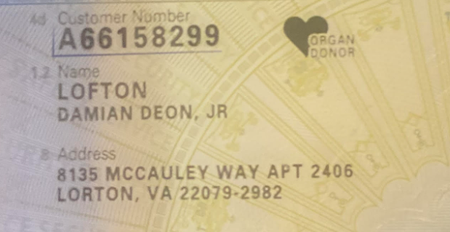Baltimore, MD 21215
INVOICE #: 1082700 SUBTOTAL: $1,294.74
ITEM # | DESCRIPTION | QUANTITY
028290 | Chips | 4 cases
028751 | Chips | 4 cases
028666 | Chips | 4 cases
010010 | Chips | 4 cases
010012 | Chips | 4 cases
010008 | Chips | 4 cases
010011 | Chips | 3 boxes
010009 | Chips | 3 boxes
027657 | Chips | 1 box

TAX: $0.00 TOTAL: $1,294.74
SHIP TO: Fort Meade
DRIVER: Andre Marques Williams
W-452-067-585-255

